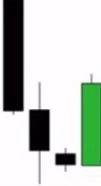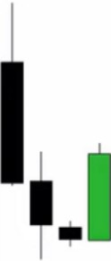**ICT Fair Value Gaps FVG**

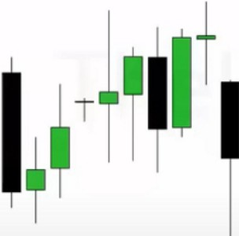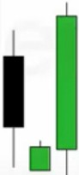

**Reinforcing Fair Value Gaps**

[Trading n ide The Range]

I

I

,,

**Fair Value Gap Left Open**

**Fair Value Gap** is a range in Price Delivery where one side of the Market Liquidity is offered and typically confirmed with a Liquidity Void on the Lower Time Frame Charts 1n the same range of Price. Price can actually "gap" to create a literal vacuum of Trading thus posting an actual Price Gap.

The gap occurs on the timeframe youre looking at, you can break it down further on smaller timeframes but then it would probably be a liquidity void and not 1 gap

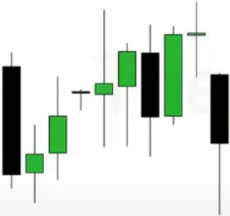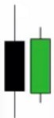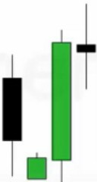

**f**

Why can we expect it to fill that gap, because we already took SSL beneath that low with a turtle soup, we have EQH there and above the EQH we have a FVG. High probability trade. December is rangey and when were range bound then this is the style of trading you want to use, looking for

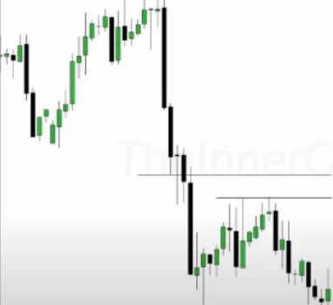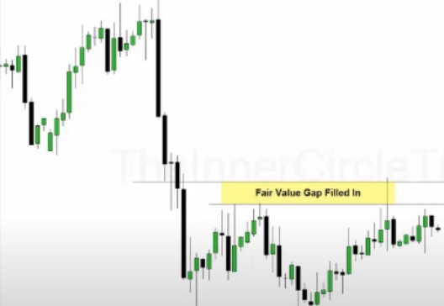

stops and looking for FVGs

Fair value gaps, liquidity void, orderblocks and liquidity pools overlap a lot

Run on liquidity, so a liquidity pool and it hits a FVG and on the lower timeframe many times this will create a liquidity void

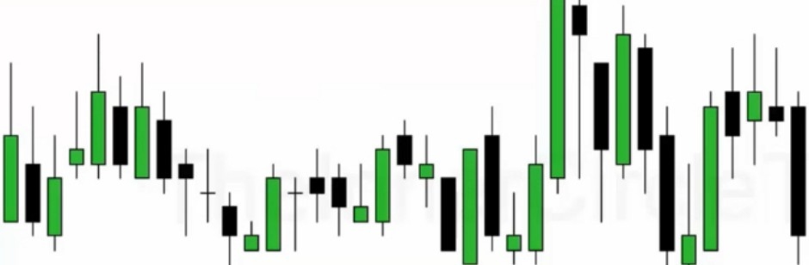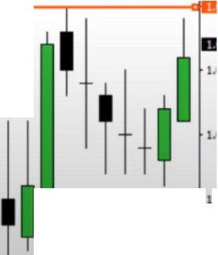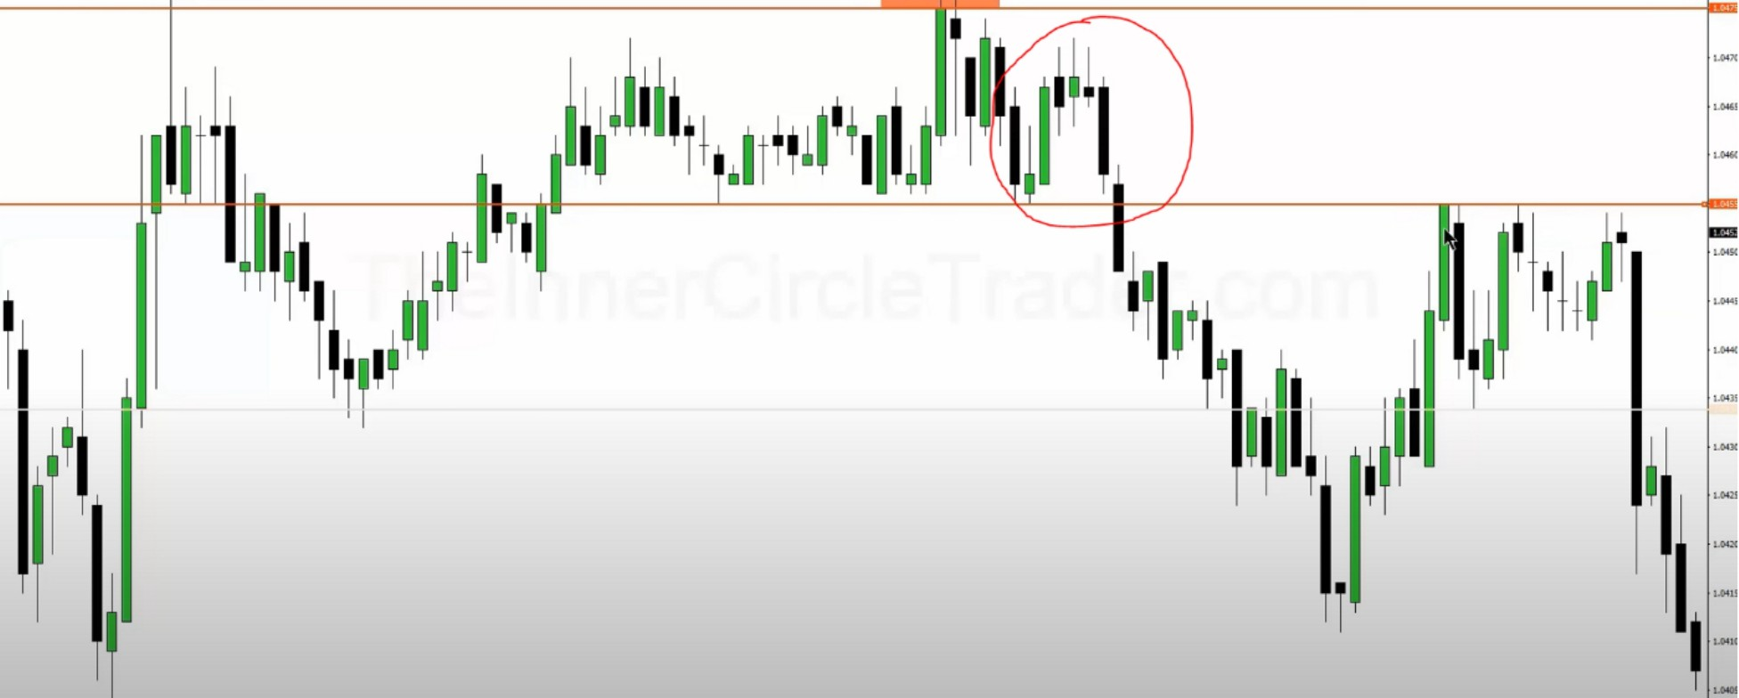

**,,, ,tl_,11,**

**1**

,.

.

*·•·•, ••,*

That circled range is already efficient price, once we break the orange line to the downside thats where only sellside is delivered

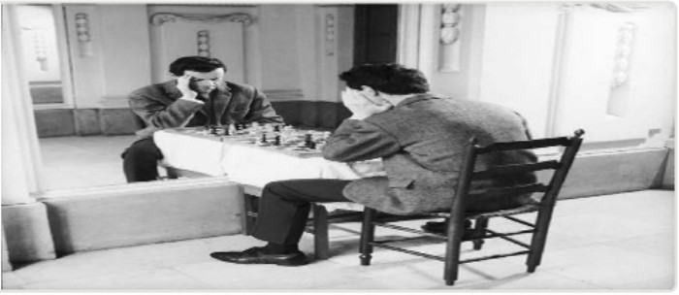Arjo I Twitter, lnstagram I Linktree

Linktree. Make your link do more.

, https://1.co/HhmmTN1fUI

JavaScript is not available.

*"!JI* https://twitter.com/arjoio